Book Marker

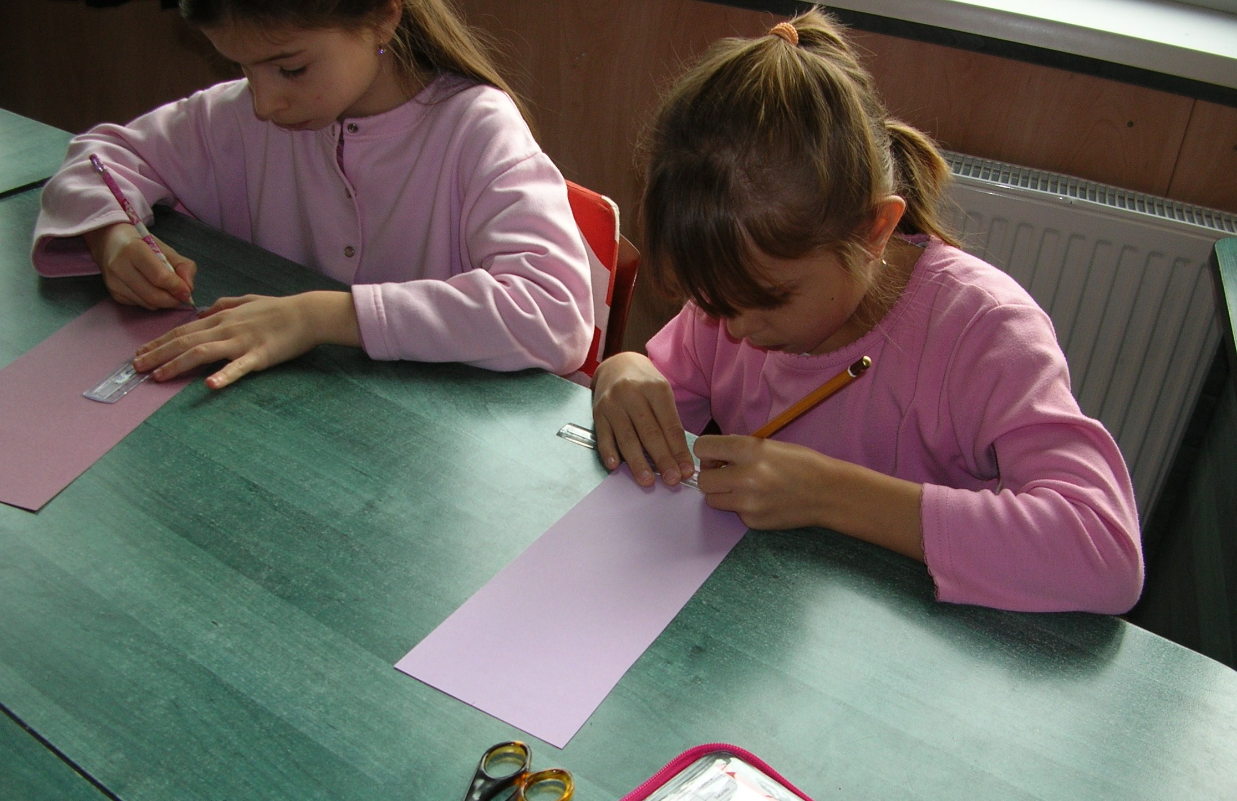 1. Measuring the cardboard paper.

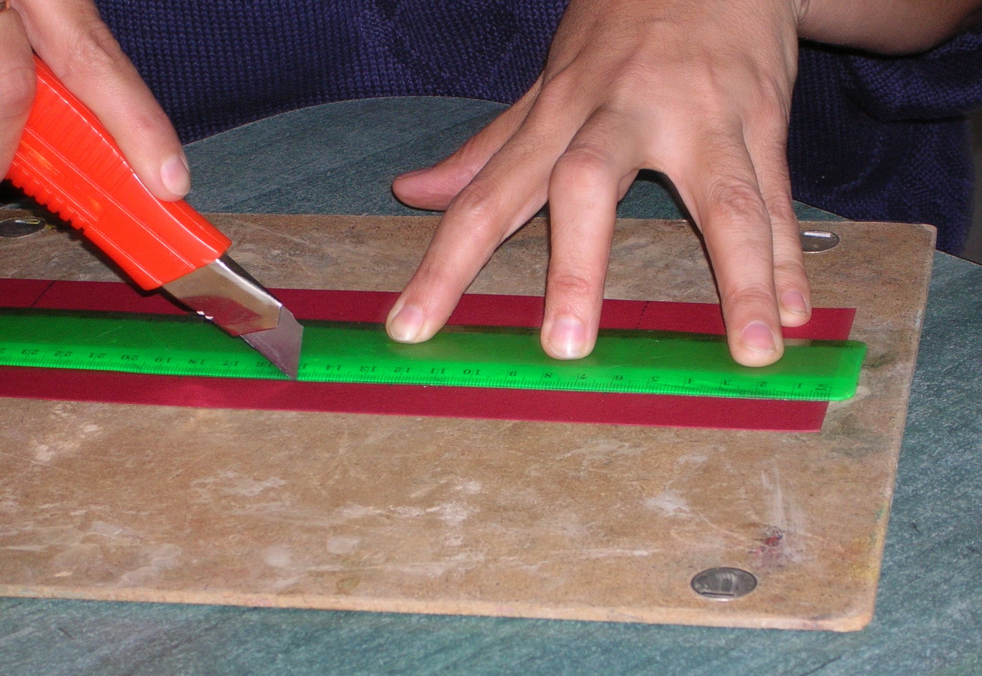 2. Cutting up the cardboard.

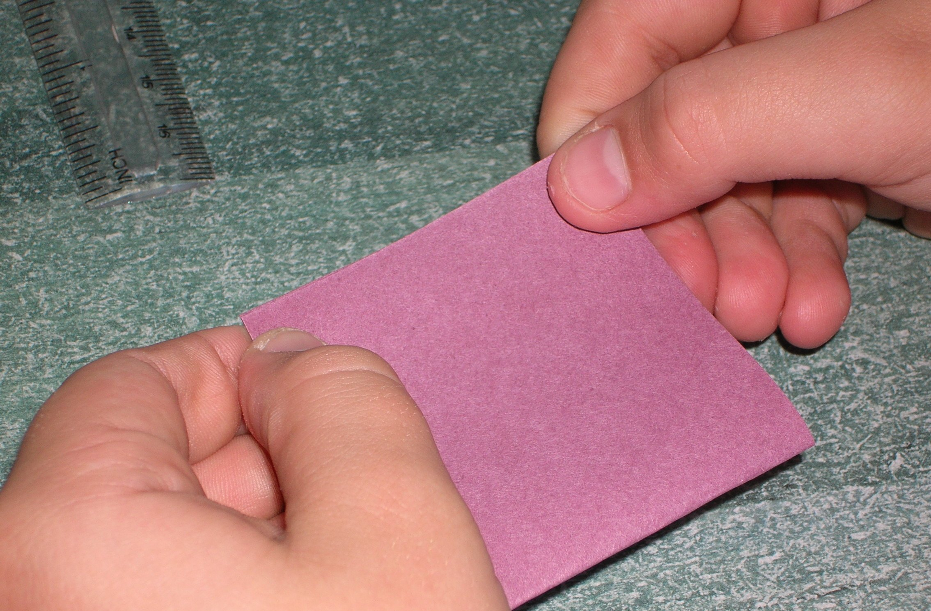 3. Folding

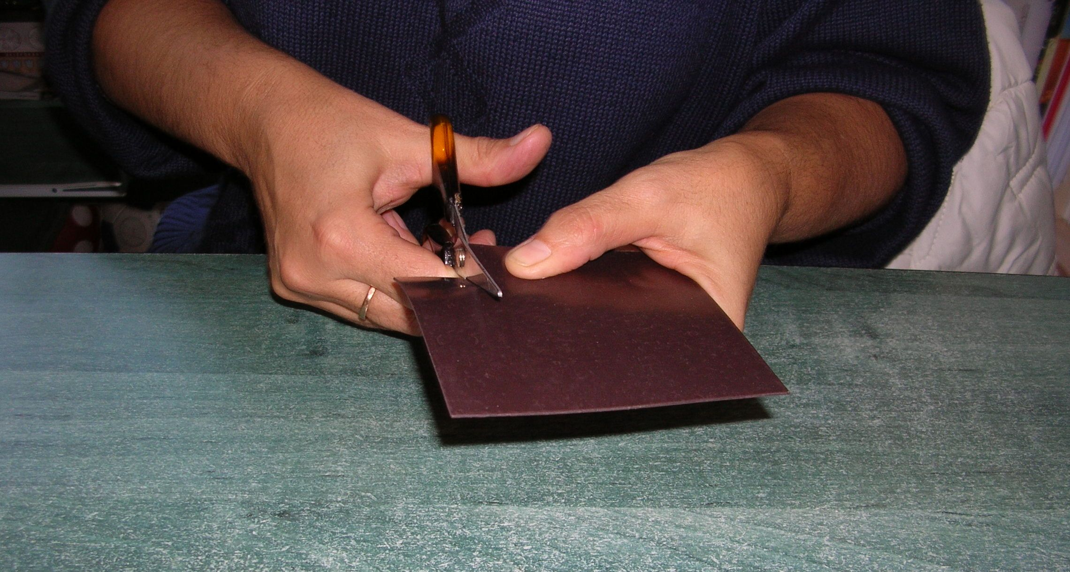 4. Cutting the magnet into pieces.

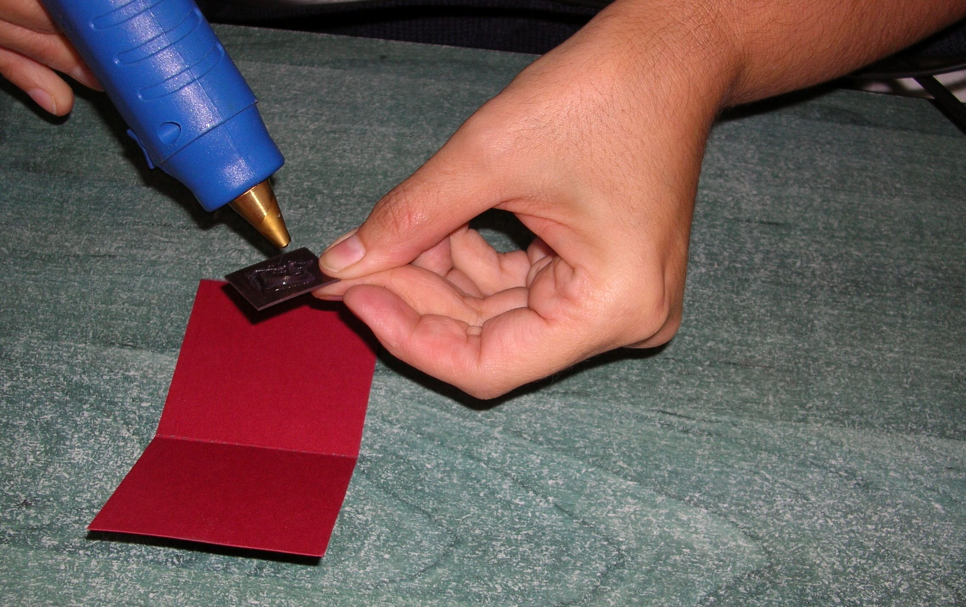 5. Sticking the magnets inside.

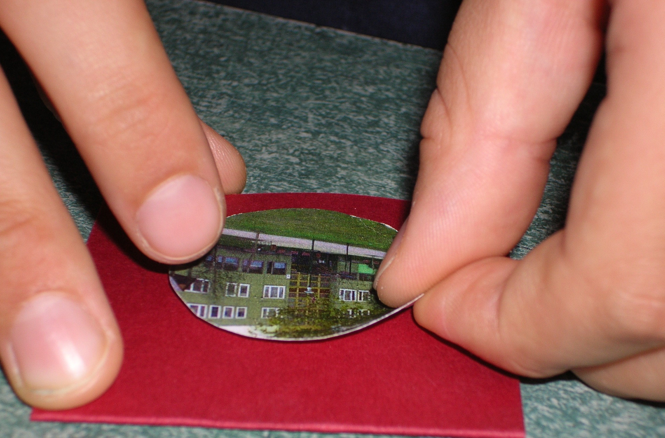 6. Putting the stickers on the outside of the card.

